1. Create a user in Github ([www.github.com](http://www.github.com))
   1. Tell me your username so I can add you as a contributor (which will allow you to work on the files)
2. Our repository (where all the files) is in <https://github.com/boonkey/AdExchange>
3. Go to <https://desktop.github.com/> and download (it's very good and very user friendly).
4. This is the main screen:  
   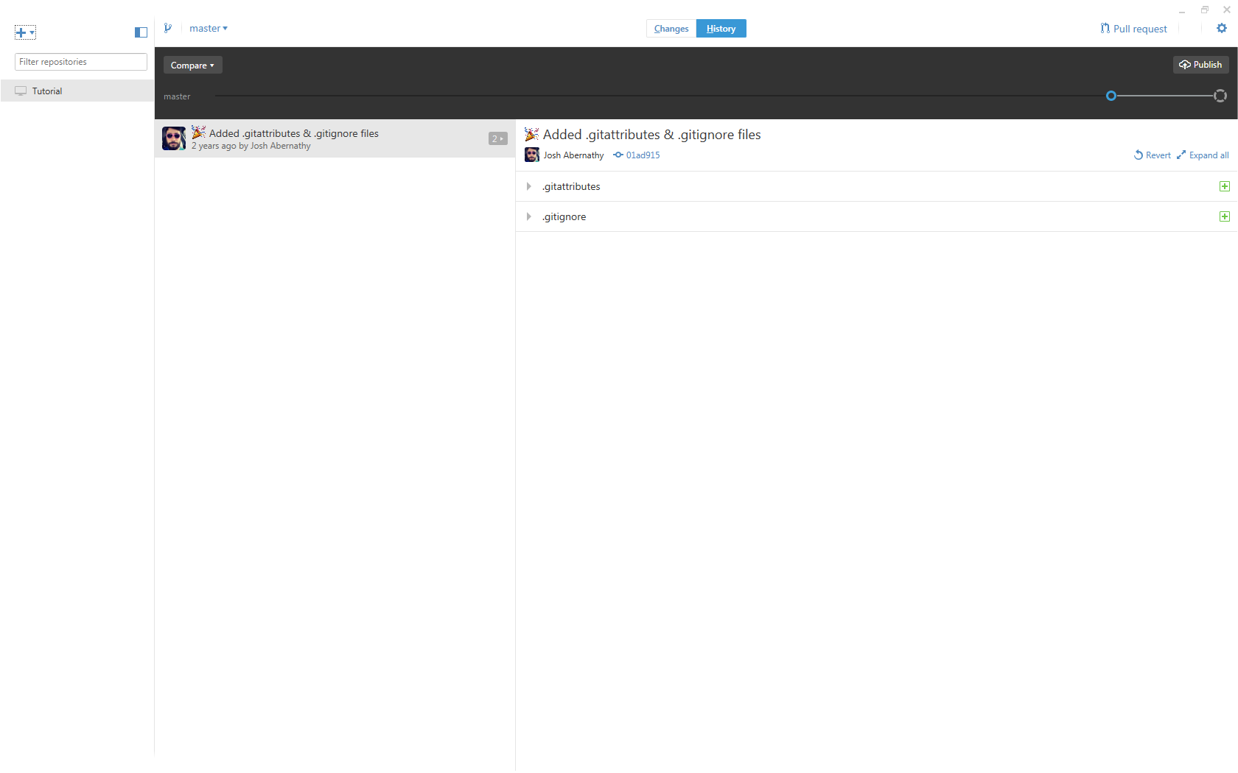
5. Click on the plus on the top left corner, and select "Clone"  
   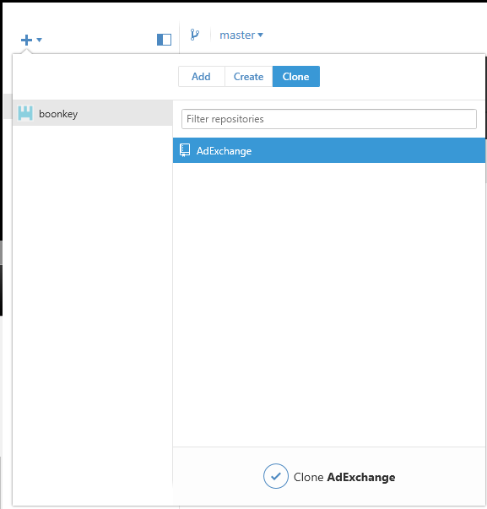
6. Select a place for the repository on your computer (it will create the folder automatically)
7. Add your changes in the local folder you chose on step 6(for example, this document)
   1. If you lost it, the software can open the folder for you
8. Return to github desktop. You'll see your changes.
   1. Select the files you want to upload
   2. Add a summery and description (**Required!**)
   3. Click "Commit to master"

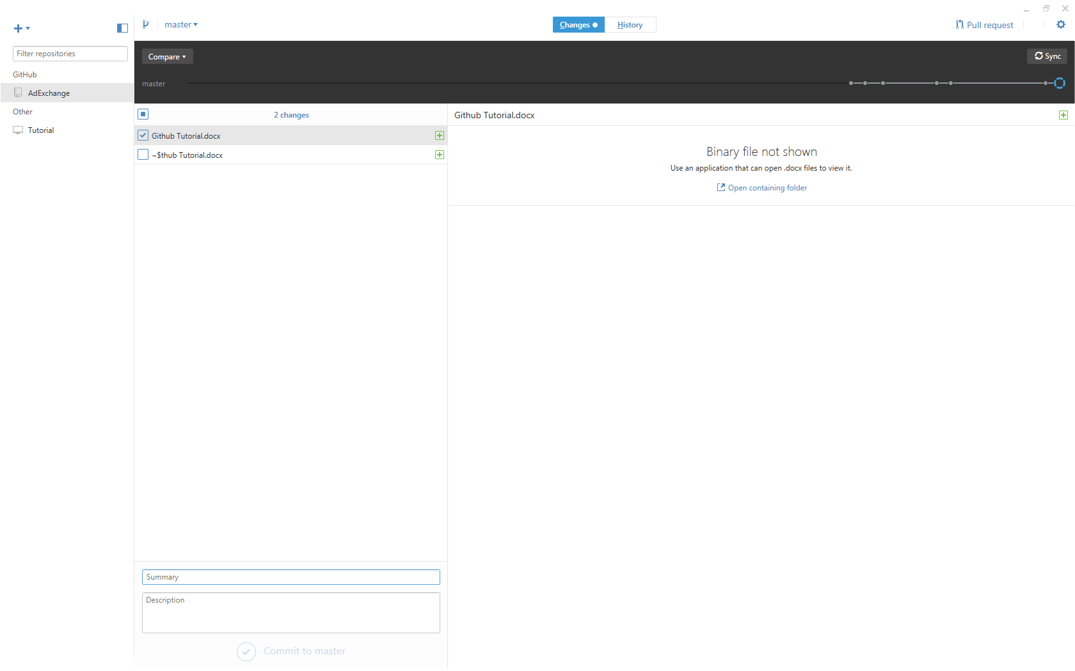

1. Now you have *staged a commit*, meaning your files are ready to be uploaded and synced with the remote repository.
   1. On the top right corner (in black) you will find "Sync" button.   
      Try and use it. It will *push* your *commit* to the *remote repository*
   2. You can also *revert* your commit, in case you made a mistake
      1. After *committing* to a change, you can only *revert* it to cancel the operation, so **make sure to commit only what you are sure is good**

